Job Description

Primary Information
Job Title | Intermediate Apprentice – Trainee Operative – Contracting (Highways Maintenance)
Division | Tarmac
CRH Leadership Level | Individual Contributor
Location(s) | United Kingdom
Function
Direct reports | N/A
Key Contacts
Hiring Manager | Business Performance & Continuous Improvement Manager, Contracting

Position Overview
Purpose and scope of the role.
The scope of our Trainee Operative – Contacting (Highways Maintenance) will see individuals work on rural and urban roads to repair damaged surfaces using hand and power tools and pedestrian plant machinery.
The apprentice will work as part of a team carrying out the repairs and individually when preparing the area for repair.
This work, using hand or power tools, could include repairs to potholes, replacement and reinstatement of pavements and kerbs, installing street ironworks and laying new surfaces to ensure roads and pathways are suitable for driving of vehicles or pedestrians to walk safely on.
Apprentices will complete a Level 2 Highways Skilled Operative Apprenticeship learning pathway, during their 1st 2 years of employment/training.

Key Tasks and Responsibilities
In this role, you will:
Monitor & Comply with CRH’s Life Saving Rules and all Health & Safety policies. Attend daily briefing sessions and Tool box talks when instructed. Display a proactive approach to Health & Safety.
Take every possible precaution to minimise the impact of our operations on the environment.
Be polite and courteous to the client and the general public.
Follow instructions given from team leader / ganger on site to ensure safe working practice and all procedures are being followed.
Act in a responsible manor on site as you are representing the company at all times.
Attend training courses as and when instructed to do so. This includes –
- You will be trained in using machinery and plant. For example; steel saws, rollers and dumpers
Willingness to learn / improve / progress within the company.
Undertake all tasks given to you to the best of your abilities.

Key Characteristics
For this role you should be/have:
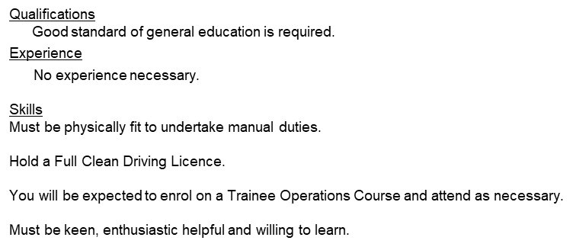

Key Functional Competencies
We want our early careers programme joiners to be individuals who’ll demonstrate -
- A drive to succeed - We empower our early careers joiners to bring the real ‘you’ to the workplace.
- Willingness to learn - We want you to grow your own way, within your day-to-day role, learning about the wider business and our industry.
- The ability to be agile - Demonstrating adaptability and having a positive impact within your teams.
- Excellent relationship building skills - Better together! You’ll be someone who values the benefits of working within a team environment, and being part of a culture where you’ll be encouraged to contribute

Tarmac / CRH Behaviours
Behaviours
Shape our future | Customer Focus - Building strong customer relationships and delivering customer-centric solutions.  Self-development - Actively seeking new ways to grow and challenge using both formal and informal development channels.
Drive our impact | Action Oriented - Taking on new opportunities and tough challenges with a sense of urgency, high energy and enthusiasm.  Drives Value - Consistently achieving results, even under tough circumstances.  Situational Adaptability - Adapting approach and demeanour in real time to match the shifting demands of different situations.
Inspire our people | Collaborates - Building partnerships and working collaboratively with others to meet shared objectives.  Communicates Effectively - Developing and delivering multi-mode communications that convey a clear understanding of the unique needs of different audiences.  Fosters Inclusivity - Recognises the value that different perspectives bring to an organisation.  Instils Trust - Gaining the confidence and trust of others through honesty, integrity, and authenticity.

Education
Educational Qualifications required for the role of Trainee Operative – Contracting (Highways Maintenance):
GCSEs A-C or numbered equivalent (9-4) in both English and Maths​

Other
Advanced Apprentices – with support from your Line Manager, you will have an individual development plan (IDP). This is a simple and effective way of keeping track of your development, identifying your needs and agreeing and implementing a solution.

